**PROJECT DEVELOPMENT PHASE**

**DELIVERY OF SPRINT -3**

|  |  |
| --- | --- |
| Date | 10 November 2022 |
| Team ID | PNT2022TMID51074 |
| Project Name | AI Based Discourse for Banking Industry |

**Actions**

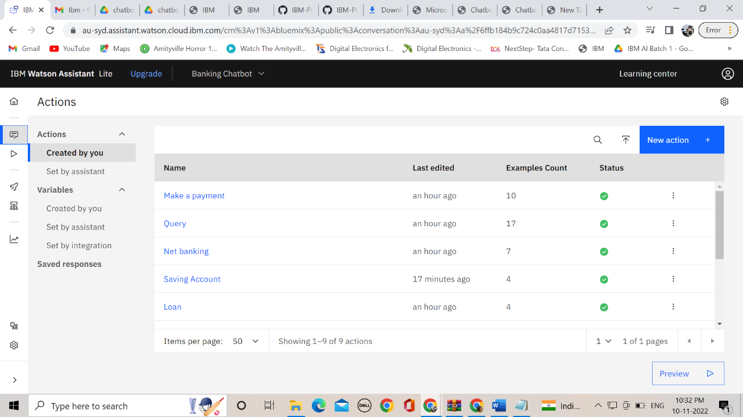

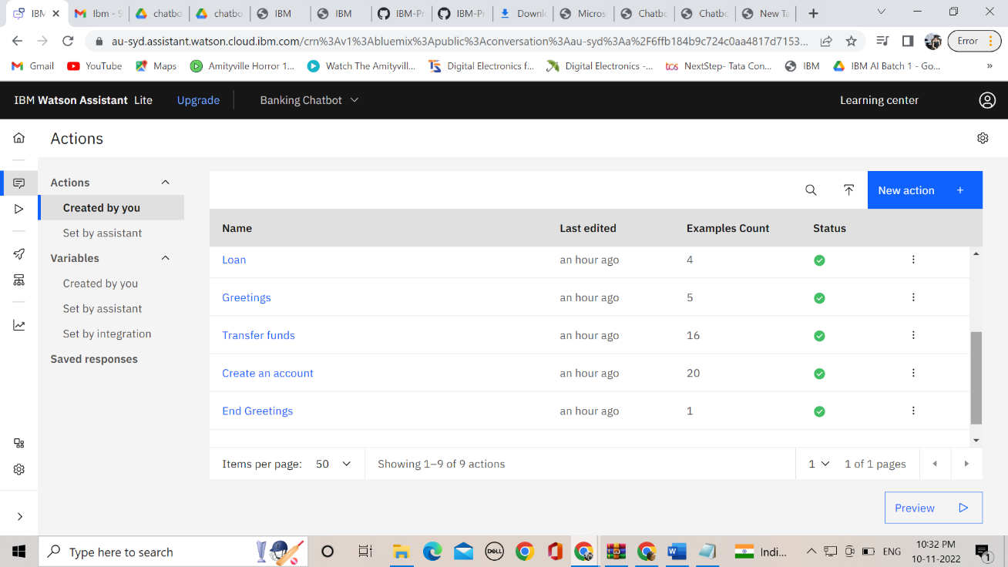

**Analysis**

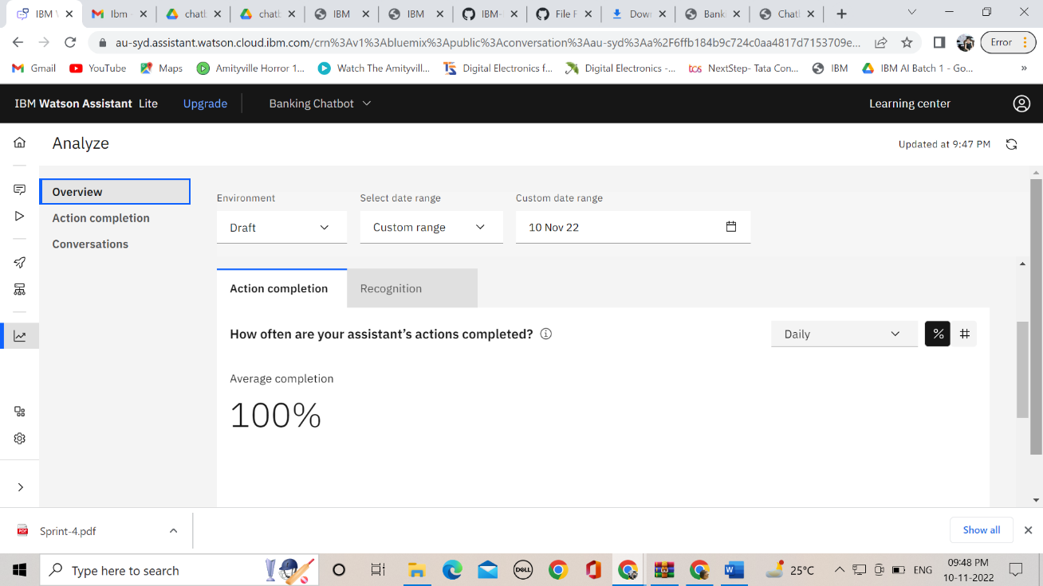

**Preview**

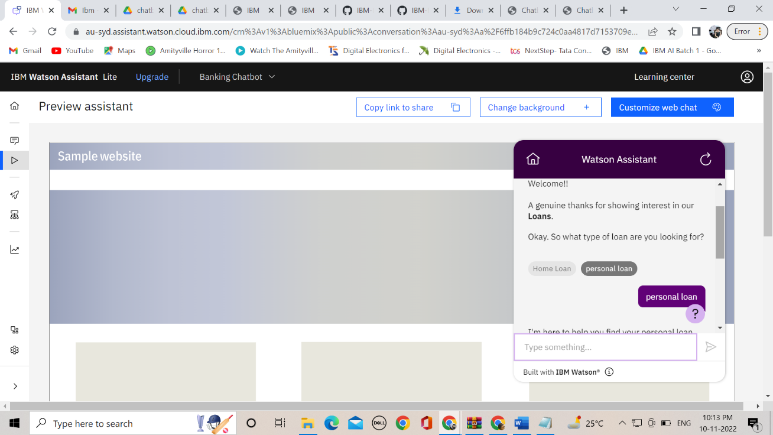

**Webpage with Flask integration**

